How to run all compiler Design assignments

Assignment 2

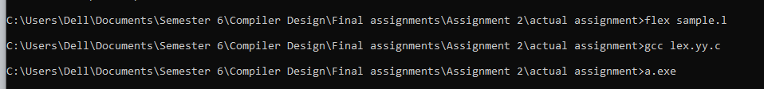

Assignment 3

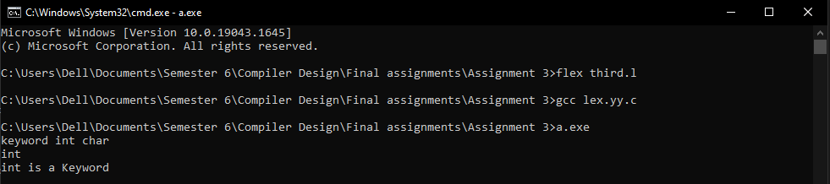

Assignment 4

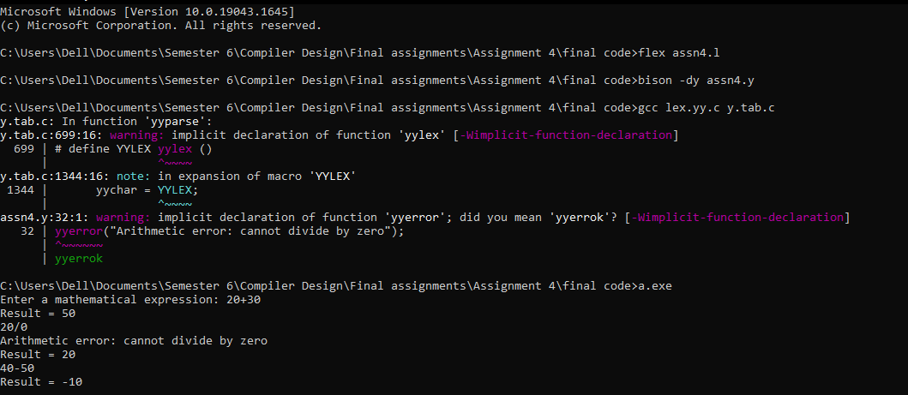

Assignment 5

